Setup the connection between EC2 and RDS database

1. Create security group for Ec2 instance with inbound rules as 22 with myIp
2. Create security group for RDS instance with inbound rules as 3306 with my ec2 sg
3. Create the RDS instance with username ,password and select the security group of RDS which we have created above
4. Create the EC2 instance with the above EC2 security group
5. Login to the Ec2 instance and install mysql client with this command (yum install mysql)

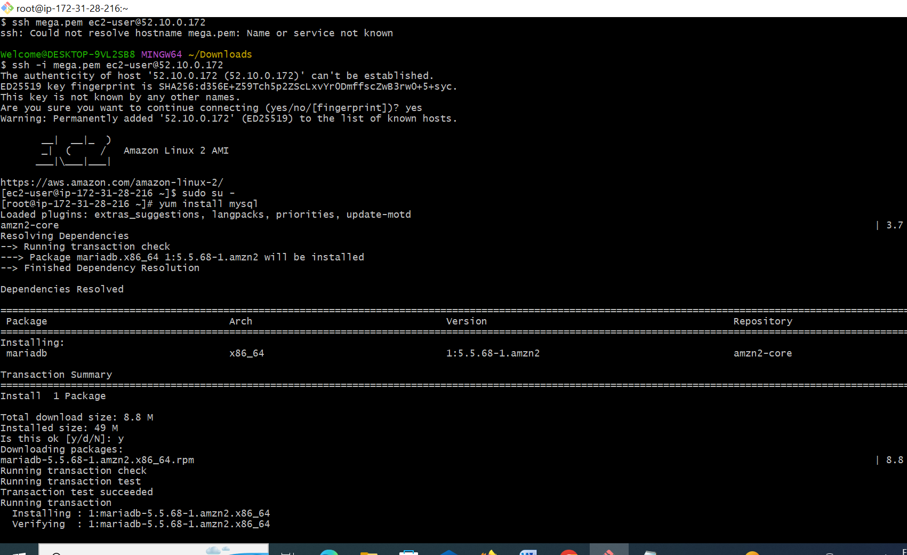

1. Run the below command to connect to RDS instance

CMD: mysql -h <RDS ENDPOINT> -P 3306 –u <username> -p

Example: mysql -h mysqladmin.czedlicecltz.us-west-2.rds.amazonaws.com -P 3306 -u mysqladmin –p

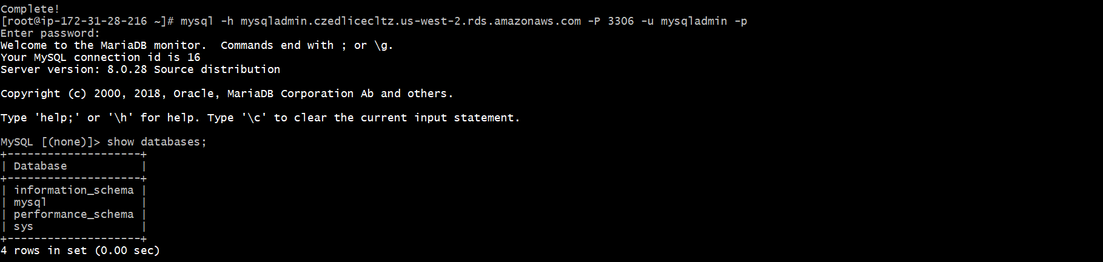

7.Enter the password and check mysql terminal is displayed

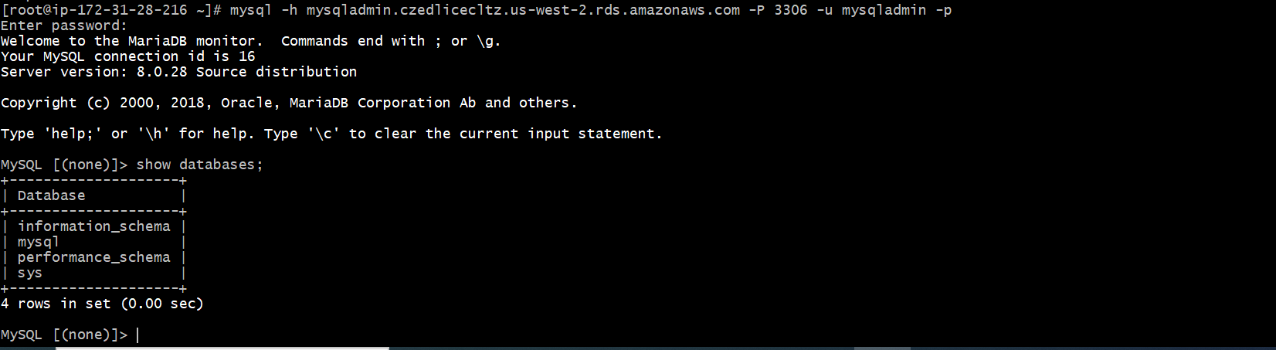

8.Create the database

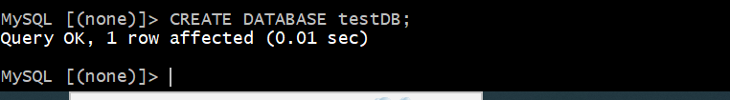

9. select the database

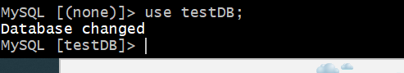

10.create the tables in the database



11.Insert the data to the tables



12.check data is inserted in to the tables

